Enterprise Google Cloud
Data Platform Blueprint
VOLUME 11
Monitoring, SRE and Operations
Enterprise Reference Architecture and Implementation Blueprint

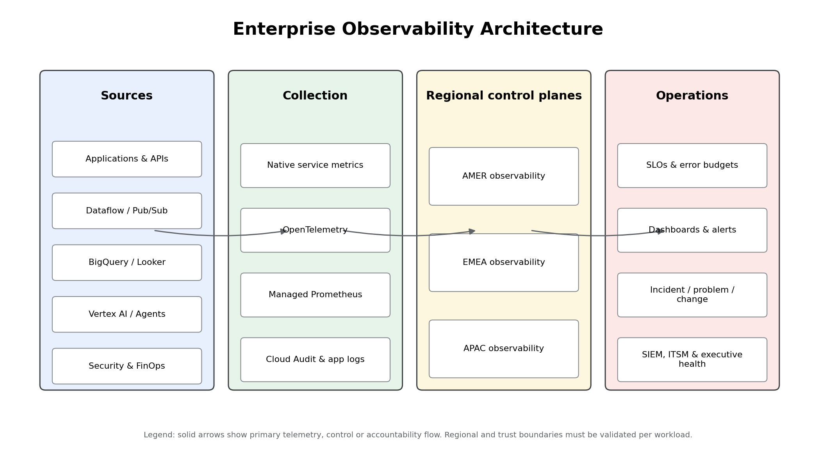
Enterprise observability, reliability and operations control model
Architecture Baseline 1.0 | 12 July 2026 | Google Cloud
Classification: Enterprise architecture reference. Validate current service capabilities, quotas, locations, retention, pricing, support and regulatory requirements before implementation.

Document Control
Field | Value
Document | Volume 11 - Monitoring, SRE and Operations
Series | Enterprise Google Cloud Data Platform Blueprint
Version | 1.0
Status | Detailed reference architecture for adaptation and implementation
Date | 12 July 2026
Owner | Enterprise Site Reliability Engineering and Operations Architecture
Approvers | CIO, CDO, CISO, Enterprise Architecture, Platform Engineering, Domain Product Owners, SRE, Security Operations, FinOps, Business Continuity and Service Management
Audience | Executives, service owners, platform/domain engineers, SRE, operations, security, data governance, FinOps, audit and vendor management
Review cycle | Quarterly and after any material incident, service/product change, regulatory change or repeated SLO failure
Primary dependencies | Volumes 01-10; Volume 12 DR and Business Continuity; Volume 13 Terraform. Volume 09 DevSecOps is an explicit implementation dependency and is not assumed complete.
Scope | Operations strategy, SRE operating model, ownership, SLIs/SLOs/SLAs, error budgets, observability, service metrics, dashboards, alerting, on-call, incident/problem/change/capacity management, readiness, resilience and support.

Guidance classification. Mandatory controls apply to Tier 0, Tier 1, Restricted and Regulated workloads unless a time-bound exception is approved. Recommended patterns are enterprise defaults. Conditional patterns require workload evidence and current product validation.

Table of Contents
Section
1. Executive Summary
2. Inherited Context, Scope and Assumptions
3. Operations Strategy
4. SRE Operating Model
5. Service, Platform and Data-product Ownership
6. Service Tiering and Critical User Journeys
7. SLIs, SLOs, SLAs and Error Budgets
8. Enterprise Observability Architecture
9. Regional Telemetry, Metrics Scopes and Residency
10. Cloud Monitoring
11. Cloud Logging
12. Managed Service for Prometheus
13. OpenTelemetry
14. Cloud Trace and Error Reporting
15. Application Metrics
16. Pipeline and Data Metrics
17. BigQuery, Dataflow and Pub/Sub Metrics
18. Vertex AI, Security and FinOps Metrics
19. Dashboard Standards and Service Health
20. Alerting Standards, Severity and Routing
21. On-call Model and Escalation
22. Runbooks and Playbooks
23. Incident Management
24. Problem and Change Management
25. Capacity and Performance Management
26. Operational and Production Readiness
27. Post-incident Review and Reliability Improvement
28. Chaos Engineering and Resilience Testing
29. Support and Vendor Escalation
30. Structured Service Assessments
31. Architecture Decision Records
32. Risks and Mitigations
33. Implementation Roadmap
34. Validation Criteria and Acceptance Tests
35. Production Readiness Checklist
36. Dependencies, Decisions and Next Actions
37. References and Companion Assets

1. Executive Summary
Volume 11 defines how the enterprise data and AI platform is operated as a portfolio of business services rather than as a collection of independent cloud resources. It establishes a federated SRE model in which central platform SRE provides common observability, incident-command and reliability governance, while platform and domain teams own their service outcomes, SLOs, runbooks and on-call response.
Executive decision: reliability is measured at the consumer boundary - freshness, quality, latency, successful analytics and AI outcomes - and is governed through SLOs and error budgets. Raw infrastructure thresholds support diagnosis but do not define service health.
Outcome | Mandatory target
Measurable service health | Every Tier 0/1 service has approved owner, critical user journeys, SLIs, SLOs, dependencies and error budget.
Actionable detection | Every page-level alert represents likely user impact or rapid SLO burn and has an exercised runbook.
Federated accountability | Central SRE owns the platform and standards; platform/domain teams own their services and consumer communication.
Regional control | Telemetry collection, storage and aggregation align with AMER, EMEA and APAC residency and access boundaries.
Operational evidence | ORR/PRR, incident response, PIR, capacity and resilience decisions are supported by reproducible evidence.
Cost and security | Telemetry is governed data with classification, retention, access, cardinality and cost controls.

- Tier 0 production objective: 99.9% to 99.99% service availability as approved, RTO < 1 hour and RPO < 5 minutes, subject to service-specific constraints.
- Tier 1 objective: RTO < 4 hours and RPO < 15 minutes; Tier 2: RTO/RPO < 24 hours.
- A telemetry blind spot is itself a high-severity reliability event for Tier 0 and Tier 1 services.

2. Inherited Context, Scope and Assumptions
- The enterprise is a global Fortune 100 organization with 10-50 PB of historical data, 50-250 TB daily growth, billions of events, hundreds of systems, thousands of pipelines and thousands of users.
- The architecture uses AMER, EMEA and APAC regional data planes, centrally governed platform capabilities and federated domain-owned data products.
- BigQuery is the primary analytical engine; Cloud Storage/BigLake provide durable and open-format data layers; Pub/Sub, Dataflow, Datastream, Dataform and Managed Airflow implement ingestion and transformation.
- Looker provides governed semantic analytics; Vertex AI and Gemini support ML, GenAI, RAG and agent workloads.
- Identity is group-based and least-privilege. Private-by-default networking, VPC Service Controls, selective CMEK, centralized audit, Terraform authority and evidence-based production gates are inherited controls.
- Security classifications are Public, Internal, Confidential, Restricted and Regulated. Telemetry inherits the highest applicable classification when it contains sensitive identifiers, prompts, queries, schemas or payload fragments.
- Volume 10 defines cost allocation and FinOps. Volume 12 defines recovery. This volume connects both through operational metrics, capacity, error budgets and incident evidence.
- Volume 9 DevSecOps has not yet been generated in this sequence. Observability-as-code and release-gate designs are defined here but remain implementation dependencies on Volume 9 and Volume 13.
Item | Classification | Volume 11 treatment
Confirmed | Master prompt scope, inherited platform services and regional data-plane model | Used as baseline.
Architecture assumption | Regional observability projects and controlled enterprise views | Default pattern pending workload/location validation.
Mandatory control | Tier 0/1 SLOs, on-call, runbooks, tested alerts, incident and PIR process | Required before production approval.
Recommended control | OpenTelemetry and managed Prometheus standards | Default for portable application metrics/traces.
Conditional capability | App Hub/Application Monitoring and advanced automated remediation | Adopt after product/location/maturity validation.
Open decision | Enterprise ITSM/SIEM/paging product integration and support-contract tiers | Resolve during implementation.

3. Operations Strategy
The operating strategy applies five principles:
- Business-service first: observe and operate the end-to-end consumer journey, not only individual Google Cloud services.
- Symptoms before causes: page on freshness, quality, availability, latency and error-budget burn; use component signals for diagnosis.
- Federated ownership: ownership follows the service/data product; shared platforms provide standard capabilities and incident command.
- Automation with guardrails: automate collection, deployment, evidence and bounded remediation; gate destructive or wide-blast-radius actions.
- Continuous learning: error budgets, PIRs, recurring-problem analysis, capacity reviews and resilience exercises drive prioritized improvement.
Operations capability | Implementation pattern | Evidence
Service registry | Service ID, tier, owner, region, data classification, dependencies, SLOs and support route | Versioned service record
Telemetry contract | Required resource attributes, metric/log/trace standards and forbidden sensitive fields | Validated schema and CI result
Reliability control | SLOs, error budgets and change policy | SLO configuration and monthly report
Incident response | Severity, command roles, communication cadence and runbooks | Incident timeline and PIR
Capacity/performance | Demand, quota, reservation, headroom and saturation reviews | Capacity model and actions
Assurance | ORR/PRR and resilience tests | Signed evidence package

4. SRE Operating Model
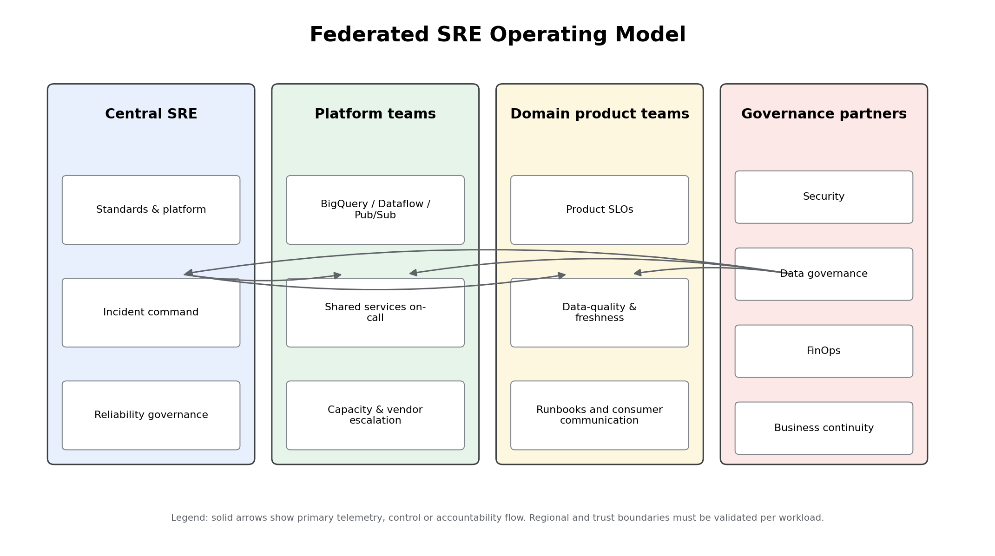
Figure 1 - Federated SRE operating model
Central SRE is a platform and governance function, not the default owner of every application or data product. It operates the regional observability foundation, defines reliability standards, leads major incidents, measures portfolio health and coaches product teams. Platform teams operate shared services. Domain teams own business semantics, freshness, quality, consumer impact and data-product response.
Role | Accountability | Minimum operational duty
Business service owner | Business impact, target service level and risk acceptance | Approve SLO, error-budget policy and major incident communication.
Platform SRE | Common platform reliability and incident command | Operate observability, on-call standards, major incident process and reliability reviews.
Platform owner | BigQuery/Dataflow/Pub/Sub/AI/analytics shared capability | Capacity, service alerts, vendor escalation and platform runbooks.
Domain product owner | Data-product reliability and consumer outcomes | Freshness/quality SLO, product on-call, reconciliation and consumer communication.
Security operations | Security monitoring and containment | Operate SIEM/SOAR, evidence preservation and security incident escalation.
FinOps | Cost anomaly and capacity economics | Monitor cost/unit economics; support commitment and capacity decisions.
Business continuity | Recovery readiness | Coordinate exercises and recovery governance with Volume 12.

5. Service, Platform and Data-product Ownership
Mandatory: no production service, pipeline, data product, dashboard, model endpoint or alert may be ownerless. Ownership must resolve to a group and an accountable executive/business service owner, not an individual-only mailbox.
Asset | Accountable owner | Responsible operator | Reliability boundary
Cloud observability foundation | Enterprise Platform SRE | Observability platform team | Collection, storage, alerting and notification availability
BigQuery shared platform | Analytics/Data Platform Owner | BigQuery platform on-call | Job success, reservation health, access and core platform dependencies
Dataflow/Pub/Sub shared platform | Streaming Platform Owner | Streaming platform on-call | Job runtime, backlog, quotas and templates
Domain data product | Domain Product Owner | Domain data engineering/on-call | Freshness, quality, schema contract, consumer impact
Looker semantic service | Analytics Product Owner | BI/analytics on-call | Explore/dashboard availability, semantic correctness and query experience
Vertex AI service | AI Product Owner | AI platform/product on-call | Endpoint availability, latency, model version and safety/evaluation controls
Security telemetry | CISO delegate | Security operations | Detection delivery, audit evidence and response
FinOps telemetry | CFO/CIO delegate | FinOps | Allocation completeness, anomalies and unit cost

Operational ownership must be synchronized with IAM groups, service catalog/CMDB, repositories, Terraform labels, dashboards, alert policies, runbooks, incident tooling and cost allocation. A quarterly drift check identifies mismatches and blocks production promotion for critical services.

6. Service Tiering and Critical User Journeys
Tier | Business impact | Availability/SLO posture | Operational coverage
Tier 0 | Material enterprise, regulatory, safety, financial or customer impact | Typically 99.95%-99.99%; RTO <1h, RPO <5m where technically supported | 24x7 on-call, rapid burn alerts, tested failover/recovery, quarterly exercises
Tier 1 | Major business process or high-value analytics/data product | Typically >=99.9%; RTO <4h, RPO <15m | 24x7 or extended coverage, product runbooks, semiannual resilience test
Tier 2 | Important but delay-tolerant service | Business-hour or approved target; RTO/RPO <24h | Business-hour response, ticketing and annual test
Tier 3 | Development, sandbox or noncritical capability | Best effort with budget/cost guardrails | No page; owner ticket and lifecycle controls

Critical user journeys are end-to-end outcomes. Examples include source event to certified data product, executive query to approved KPI, regulated report production, AI request to grounded response, and high-severity finding to SIEM case. Each journey has an owner, dependency map, instrumentation and approved exclusions.
Anti-pattern: assigning Tier 0 to every component. Tiering applies to the business service; components inherit operational priority only when their failure threatens the service objective.

7. SLIs, SLOs, SLAs and Error Budgets
Term | Enterprise definition | Use
SLI | Measured ratio, distribution or time-based indicator of service behavior | Quantifies availability, latency, freshness, quality, correctness or telemetry health.
SLO | Internal reliability target over a defined window | Balances reliability with delivery speed and drives alerts/change policy.
SLA | External or contractual commitment with remedies or consequences | Approved by legal/commercial authorities; normally less aggressive than internal SLO.
Error budget | Permitted unreliability: 1 minus SLO, expressed over the window | Governs release risk, reliability investment and exception approval.

Service type | Primary SLI | Important companion indicators
Streaming data product | p99 event-time-to-certified latency and successful record ratio | Pub/Sub backlog, Dataflow system lag, DLQ, duplicates, reconciliation
Batch data product | Completion before cutoff, freshness and critical quality pass ratio | DAG duration, task retries, source completeness
BigQuery analytics | Successful valid queries and p95/p99 response experience | Queued time, slots, bytes processed, reservation saturation
Looker/BI | Dashboard/explore success and time-to-first-result | Cache behavior, query errors, underlying BigQuery health
Vertex AI endpoint | Success rate and p95/p99 latency | Endpoint traffic, compute, model version, drift/evaluation and dependency health
Observability foundation | Critical telemetry delivered and page notifications acknowledged | Collector drops, sink errors, canary age, notification tests

Error-budget policy: at 50% budget consumed early in the window, review reliability risk; at 75%, require owner action; at 100%, freeze nonessential risky change until the budget recovers or accountable exception is approved.

7.1 Representative SLI and SLO Catalog
ID | Service/Product | SLI Category | Measurement | Target | Window | Owner | Alert/Action | Notes
SLO-001 | Tier 0 data-product freshness | Freshness | p99 age of latest certified partition | 99.95% <= 5 min | 30-day rolling | Domain Product Owner | Page at 2x/1h or 6x/6h burn | Excludes approved source outage
SLO-002 | Tier 1 batch completion | Timeliness | Successful critical DAG runs before business cutoff | 99.9% | 30-day rolling | Data Engineering | Page if cutoff at risk; ticket on isolated failure | Runbook includes source reconciliation
SLO-003 | Streaming event processing | Latency | p99 event-time-to-curated latency | 99.9% <= 120 sec | 28-day rolling | Streaming Platform | Page on sustained backlog/lag burn | Measured at data-product boundary
SLO-004 | BigQuery interactive analytics | Availability | Successful interactive query jobs | 99.9% | 30-day rolling | Analytics Platform | Ticket on regional or reservation degradation | Excludes invalid user SQL
SLO-005 | Vertex AI online prediction | Availability/latency | Successful requests and p95 latency | 99.9%; p95 <= approved target | 30-day rolling | AI Platform | Page on availability or latency burn | Per endpoint risk tier
SLO-006 | Observability pipeline | Telemetry health | Critical metrics/logs/traces delivered within 5 min | 99.95% | 30-day rolling | Observability Platform | Page on telemetry blind spot | Synthetic canaries required
SLO-007 | Security detection delivery | Detection timeliness | High-severity findings delivered to SIEM | 99.95% <= 5 min | 30-day rolling | Security Operations | Page on sink or routing failure | Separate from incident response SLA
SLO-008 | Cost allocation completeness | FinOps quality | Daily spend allocated to owner/product/cost-center | 99.5% | Calendar month | FinOps | Ticket when unknown allocation >0.5% | Based on billing export

The complete editable catalog is included in matrices/sli_slo_catalog.csv. Production SLOs must define measurement query, window, exclusions, owner, alerting behavior, maintenance policy and consumer impact.

8. Enterprise Observability Architecture

Figure 2 - Enterprise observability architecture
Plane | Capabilities | Primary controls
Instrumentation | Native service metrics/logs; OpenTelemetry; Prometheus format; structured application events | Telemetry contract, service identity, sensitive-field filtering, label budget
Collection | Regional collectors, managed collectors, service integrations and audit log routing | Private/controlled egress, retries, queues, canaries, least privilege
Storage/control | Cloud Monitoring metrics scopes, regional Cloud Logging buckets, trace/error backends | Residency, retention, IAM, VPC Service Controls validation, cost controls
Reliability | SLIs/SLOs, error budgets, dashboards, alerts, uptime and synthetic checks | Ownership, runbook links, tested notification paths, versioned configuration
Operations | On-call, incident command, problem/change/capacity, resilience and vendor support | Severity model, evidence, PIR, approval and continuous improvement
Consumers | SRE, service owners, security operations, FinOps, executives and audit | Purpose-based views and separation of duties

9. Regional Telemetry, Metrics Scopes and Residency
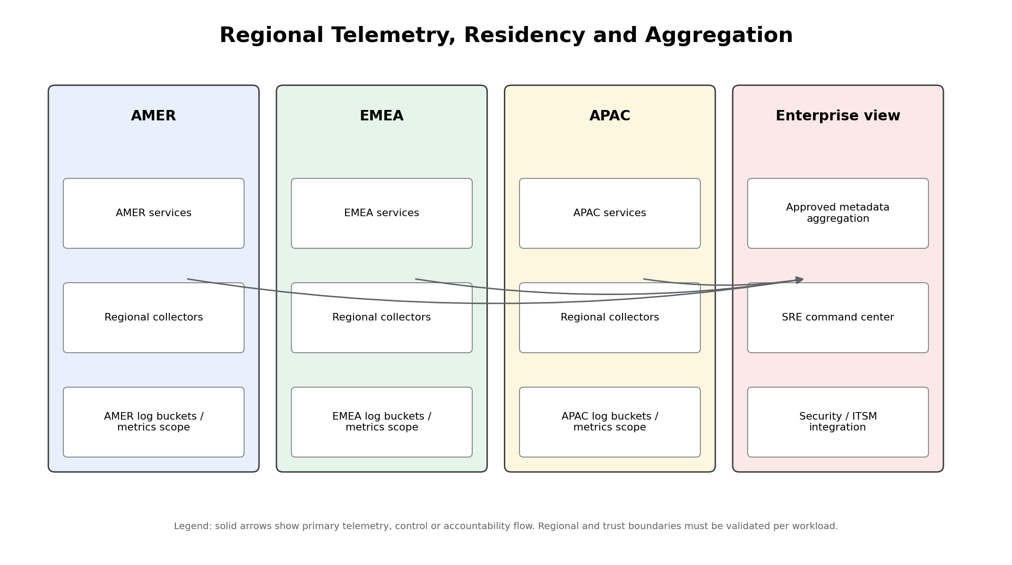
Figure 3 - Regional telemetry topology and controlled enterprise aggregation
Each geography uses a designated observability project and regional logging location. Cloud Monitoring metrics scopes provide multi-project visibility under a scoping project. Enterprise aggregation includes only approved operational metadata and avoids copying sensitive log payloads across boundaries unless legal, privacy and security approvals exist.
Data plane | Default observability pattern | Enterprise aggregation
AMER | AMER scoping project, regional log buckets, regional collectors and notification channels | Portfolio SLO status, incident state, selected capacity and cost KPIs
EMEA | EMEA scoping project and EMEA-approved log location, access groups and collectors | Approved metadata only; no regulated payload export without control mapping
APAC | APAC scoping project, regional log buckets and collectors | Approved metadata only, with country-specific validation where required
Global/shared services | Dedicated global/shared control project where a service is inherently global and approved | Service health and dependency signals linked to regional consumers

Implementation dependency: validate current Monitoring/Logging data-location characteristics, metrics-scope quotas, supported regions and perimeter behavior during detailed design. The architecture does not assume that every telemetry type can be pinned identically.

10. Cloud Monitoring
Cloud Monitoring is the primary managed metrics, dashboard, service-monitoring and alerting control plane. Regional scoping projects provide controlled visibility into platform and domain projects. Policies, dashboards, SLOs and notification metadata are maintained as code and carry owner, service, environment, region, severity and runbook labels.
- Use native service metrics before creating duplicates.
- Create custom metrics only for business-service outcomes such as freshness, quality, certification, reconciliation and incident state.
- Prefer distributions for latency; ratios for availability/quality; time-since-last-good for freshness.
- Monitor the observability system itself through synthetic canaries, policy inventory, API errors and notification tests.
- Do not page on CPU, slots or queue depth alone unless it is a proven leading indicator of imminent user impact.
Representative Terraform alert policy. Full source includes prerequisites, runbook metadata, controlled auto-close and lifecycle protection.
# Purpose: SLO-aligned Pub/Sub backlog alert example.
# Prerequisites: notification channel and project APIs are provisioned.
resource "google_monitoring_alert_policy" "pubsub_backlog" {
project = var.observability_project_id
display_name = "prod-streaming-pubsub-oldest-unacked-age"
combiner = "AND"

documentation {
content = "Runbook: ${var.runbook_base_url}/STR-002"
mime_type = "text/markdown"
}

conditions {
display_name = "Oldest unacked message age exceeds product threshold"
condition_threshold {
filter = "resource.type=\"pubsub_subscription\" AND metric.type=\"pubsub.googleapis.com/subscription/oldest_unacked_message_age\" AND resource.label.subscription_id=monitoring.regex.full_match(\"prod-.*\")"
comparison = "COMPARISON_GT"
threshold_value = var.oldest_unacked_seconds
duration = "300s"

aggregations {
alignment_period = "60s"
per_series_aligner = "ALIGN_MAX"
cross_series_reducer = "REDUCE_MAX"
group_by_fields = ["resource.label.subscription_id"]
}

trigger { count = 1 }
}
}

notification_channels = [var.primary_oncall_channel]
user_labels = {
severity = "high"
service = "streaming-platform"
runbook_id = "str-002"
owner = "data-platform-sre"
}

alert_strategy {
auto_close = "1800s"
notification_rate_limit { period = "300s" }
}

11. Cloud Logging
Cloud Logging provides the enterprise operational and audit event pipeline. Organization and folder sinks route production telemetry to regional buckets and approved security, analytics or archive destinations. Routing is designed before workload onboarding because sink behavior is not a retroactive recovery mechanism for logs that were never routed.
Log class | Default retention/route principle | Access
Administrative and audit | Retain according to regulatory/control requirements; export to security evidence destination | Security/audit and restricted platform roles
Tier 0/1 application operations | Regional bucket with incident and troubleshooting retention | Service owner and SRE, purpose-scoped
Debug/verbose | Short retention, sampled or excluded from central storage when safe | Engineering, nonproduction by default
Data-quality and lineage events | Retain with product evidence and governance metadata | Domain, governance and SRE
AI prompts/responses | Do not log raw content by default; use safe hashes, policy decisions and evaluation metadata | Restricted AI/security roles

Regional logging bucket and organization sink example. Validate filter, writer identity, location and retention against the enterprise control mapping.
# Purpose: Regional operational log bucket and organization-level sink.
# Security: the sink writer receives only bucketWriter on the destination bucket.
resource "google_logging_project_bucket_config" "regional_ops" {
project = var.logging_project_id
location = var.region
bucket_id = "egcdp-ops-${var.region}"
retention_days = var.retention_days
description = "Regional production operations and audit telemetry"
locked = var.lock_retention
}

resource "google_logging_organization_sink" "regional_ops" {
name = "egcdp-prod-${var.region}-ops"
org_id = var.organization_id
destination = "logging.googleapis.com/projects/${var.logging_project_id}/locations/${var.region}/buckets/${google_logging_project_bucket_config.regional_ops.bucket_id}"
include_children = true
filter = <<-EOT
resource.labels.location="${var.region}"
AND severity>=DEFAULT
AND NOT jsonPayload.telemetry_class="debug_nonprod"
EOT
}

resource "google_project_iam_member" "sink_writer" {
project = var.logging_project_id
role = "roles/logging.bucketWriter"
member = google_logging_organization_sink.regional_ops.writer_identity
}

12. Google Cloud Managed Service for Prometheus
Managed Service for Prometheus is selected for Prometheus-compatible workload metrics, particularly GKE, hybrid and open-source services. Managed collection is preferred where supported. Self-deployed collectors require an approved exception and operational model.
Control | Standard
Metric naming | Prometheus/OpenTelemetry semantic conventions and enterprise prefixes for custom business metrics.
Labels | No direct personal identifiers; bounded service, region, environment, version and owner labels.
Cardinality | Estimated before release and continuously monitored; uncontrolled IDs are prohibited.
Scrape interval | Aligned to detection requirement and cost; faster is not automatically better.
PromQL | Rules are peer-reviewed, tested against absent/noisy data and maintained as code.
Ownership | Platform owns backend and templates; workload team owns target instrumentation and scrape health.

Illustrative multi-window burn-rate PromQL. Production thresholds must be derived from the approved SLO and alert policy.
# Purpose: multi-window burn-rate signal for a 99.9% availability SLO.
# Replace metric and labels with the approved service contract.
(
(
1 -
sum(rate(http_server_requests_total{service_name="analytics-api",code!~"5.."}[1h]))
/
sum(rate(http_server_requests_total{service_name="analytics-api"}[1h]))
) / (1 - 0.999)
) > 2
and
(
(
1 -
sum(rate(http_server_requests_total{service_name="analytics-api",code!~"5.."}[6h]))
/
sum(rate(http_server_requests_total{service_name="analytics-api"}[6h]))
) / (1 - 0.999)
) > 6

13. OpenTelemetry
OpenTelemetry is the enterprise instrumentation and collection standard for new applications, APIs and agent/tool services. It is an open supporting technology rather than a Google Cloud managed service. Regional gateway collectors implement filtering, enrichment, batching, retries and export to managed backends.
Required resource attribute | Example | Purpose
service.name | finance-position-api | Stable service identity
service.version | 2026.07.12-3 | Release comparison and rollback analysis
deployment.environment | prod | Environment separation
cloud.region | us-central1 | Regional diagnosis and residency
egcdp.owner | grp-fin-data-product | Ownership and routing
egcdp.service_tier | tier0 | Priority and readiness policy

Prohibited by default: raw prompts, response bodies, authentication tokens, email addresses, user IDs and arbitrary high-cardinality business keys in metric labels or trace attributes.
Regional OpenTelemetry gateway baseline with memory limits, batching, resource enrichment and removal of sensitive attributes.
# Purpose: Regional OpenTelemetry gateway collector baseline.
# Validate exporter names and credentials against current Google Cloud documentation.
receivers:
otlp:
protocols:
grpc:
endpoint: 0.0.0.0:4317
http:
endpoint: 0.0.0.0:4318

processors:
memory_limiter:
check_interval: 5s
limit_mib: 1536
spike_limit_mib: 384
resource:
attributes:
- key: deployment.environment
value: prod
action: upsert
- key: cloud.region
from_attribute: gcp.cloud_region
action: insert
attributes/security_filter:
actions:
- key: enduser.id
action: delete
- key: http.request.body
action: delete
- key: gen_ai.prompt
action: delete
batch:
send_batch_size: 8192
timeout: 5s

exporters:
googlecloud:
project: egcdp-obs-amer-prod
user_agent: egcdp-otel-gateway/1.0
googlemanagedprometheus:
project: egcdp-obs-amer-prod

extensions:
health_check:
endpoint: 0.0.0.0:13133

service:
extensions: [health_check]
telemetry:
logs:
level: info
pipelines:
traces:
receivers: [otlp]
processors: [memory_limiter, resource, attributes/security_filter, batch]
exporters: [googlecloud]
metrics:
receivers: [otlp]
processors: [memory_limiter, resource, attributes/security_filter, batch]
exporters: [googlemanagedprometheus]
logs:
receivers: [otlp]
processors: [memory_limiter, resource, attributes/security_filter, batch]
exporters: [googlecloud]

14. Cloud Trace and Error Reporting
Cloud Trace supports latency and dependency diagnosis for instrumented applications and orchestration flows. Error Reporting groups supported application errors for triage. Neither replaces SLO measurement, logs, incident management or product-level quality controls.
Capability | Use | Guardrail
Distributed traces | Critical API and agent journeys, asynchronous handler correlation and latency analysis | Risk-based sampling; no payload or secret leakage
Trace-log correlation | Trace ID in structured logs and supported telemetry | Correlation ID must not be a personal identifier
Error grouping | New or rapidly recurring software errors | Do not page every exception; route based on user impact
Release comparison | Service/version attributes on traces/errors | Version metadata mandatory for production
Managed data services | Use native metrics/logs where tracing is not exposed | Do not invent unsupported span detail

15. Application Metrics
Signal type | Required examples | Operational use
Traffic | Requests, events, rows, bytes, tokens, active consumers | Demand, capacity and impact scope
Errors | 5xx/timeout, invalid contract, failed tasks, rejected writes | Availability and correctness
Latency | p50/p95/p99 request, event and processing latency | User experience and bottlenecks
Saturation | CPU/memory/worker/queue/slot/concurrency utilization | Capacity and imminent risk
Business outcome | Freshness good/total, certification, reconciliation, report completion | Primary service SLI
Dependency | Downstream error, timeout and circuit-breaker state | Root cause and blast radius

Application instrumentation must be asynchronous/non-blocking where practical. Telemetry failure must not cause the business transaction to fail unless the telemetry is itself a mandatory control, such as regulated audit evidence. In that case, the fail-open/fail-closed decision is documented in the service threat model.

16. Pipeline and Data Metrics
Domain | Core signals | Page/ticket behavior
Orchestration | DAG/task success, duration, retries, schedule delay, cutoff risk | Page when Tier 0/1 cutoff or dependency is threatened
Streaming | Input/output rate, system lag, backlog, watermark, DLQ, duplicate/replay indicators | Page on user-impacting latency burn; ticket on capacity trend
Batch/Dataflow/Spark | Job state, worker utilization, skew, failed records, reconciliation | Page critical job failure; ticket recurring inefficiency
Data freshness | Age of latest approved partition/event and source-to-product latency | Primary page-level symptom for data products
Data quality | Critical rule pass, completeness, validity, uniqueness, schema/contract | Block certification/page according to product tier
Lineage/metadata | Lineage event delivery, catalog registration, ownership drift | Ticket unless audit/control gap creates high impact
Consumer usage | Queries, reports, API consumers and last successful access | Impact analysis and deprecation decisions

Do not infer correctness from pipeline success. A green job with stale, incomplete or duplicated business data is a failed service outcome.

17. BigQuery, Dataflow and Pub/Sub Metrics
Service | Required operational signals | Correlation pattern
BigQuery | Job success/error, query latency, queued time, slot utilization, bytes processed, reservation/assignment health, storage growth | Correlate query/job labels with service, product, user persona, reservation and release.
Dataflow | Job state, system lag, data freshness, throughput, worker utilization, autoscaling, errors and custom Beam counters | Correlate with Pub/Sub backlog, source rate, release and downstream writes.
Pub/Sub | Oldest unacked message age, undelivered messages, delivery attempts, publish/ack rates, dead-letter activity and quota errors | Correlate subscription to pipeline, region, data product and consumer SLO.

Service dashboards must distinguish workload errors from service/platform errors. BigQuery invalid SQL and authorization failures are tracked separately from platform availability. Pub/Sub metric gaps are handled through multiple indicators and telemetry canaries. Dataflow custom counters are versioned with the pipeline contract.
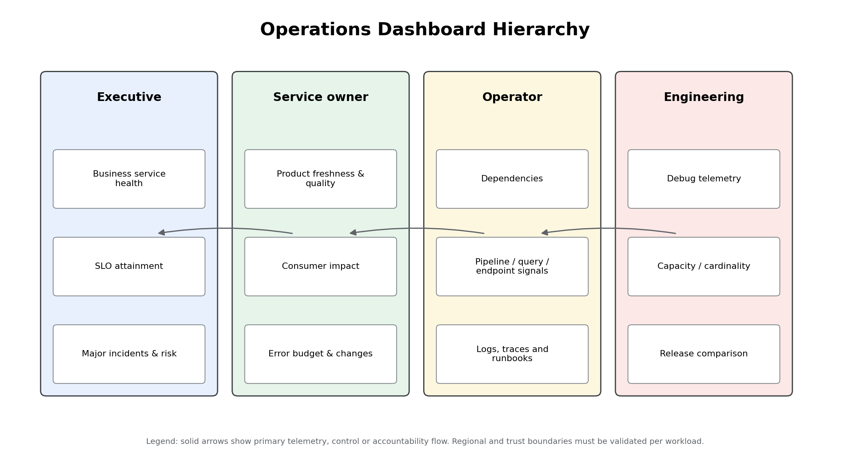
Figure 4 - Dashboard hierarchy from engineering detail to executive service health

18. Vertex AI, Security and FinOps Metrics
Area | Signals | Ownership
Vertex AI online services | Request count, response errors, latency, endpoint/resource utilization, model/version, dependency and quota signals | AI platform/product owner
MLOps/LLMOps | Pipeline success, registry/deployment state, evaluation threshold, drift/feature drift, prompt/model version | AI platform and responsible-AI governance
RAG/agents | Retrieval success, grounding/citation coverage, tool errors, policy/guardrail decisions, token/latency and human-escalation rate | AI product owner and security
Security | Audit delivery, SCC findings, VPC SC denials, key/secret access, sink health, privileged activity and containment actions | Security Operations
FinOps | Spend, forecast, anomaly, reservation/commitment utilization, telemetry cost, allocation completeness and unit economics | FinOps and resource owner

Security and cost signals usually create security incidents or operational tickets, not availability pages. They become page-level when a mandatory control fails, evidence is at risk, or business service impact is imminent.

19. Dashboard Standards and Service Health
- One dashboard has one audience and decision purpose.
- Top row shows user impact, SLO status, incident state and regional scope.
- Component metrics follow the dependency path; raw log panels are links, not substitutes for metrics.
- Every production dashboard shows owner, service ID, environment, region, SLO, runbook and last review date.
- Use consistent units, time zones, percentile labels, missing-data behavior and change/release annotations.
- Executive dashboards show business services and risk, not CPU charts.
Dashboard | Primary Audience | Required Content | Cadence | Design Guardrail
Executive service health | Executives and product leaders | Tier health, SLO attainment, major incidents, risk, business impact | Daily/real time | No raw infrastructure noise
SRE command center | SRE and incident command | Active incidents, burn rates, telemetry health, regional status, dependencies | Real time | Single source during incidents
Data-product health | Domain owners and stewards | Freshness, quality, volume, lineage events, consumer impact | Real time/daily | Per product and region
Pipeline operations | Data engineering | DAG status, Dataflow lag, Pub/Sub backlog, retries, DLQ, reconciliation | Real time | Correlated by pipeline ID
Analytics operations | Analytics platform | BigQuery jobs, queued time, reservation utilization, BI health, query failures | Real time/daily | Separate user errors from platform errors
AI operations | AI platform | Endpoint traffic, latency, errors, model/drift/evaluation signals, token usage | Real time/daily | Segment by model/version/risk tier
Security operations | SOC | Audit, SCC findings, perimeter denials, key access, sink health | Real time | Security-owned access
FinOps operations | FinOps and owners | Spend, forecast, anomaly, unit cost, allocation completeness | Daily/monthly | No paging except control failure

Representative SRE command-center dashboard definition. Production dashboards must be deployed and reviewed as code.
{
"displayName": "EGCDP SRE Command Center",
"mosaicLayout": {
"columns": 12,
"tiles": [
{
"width": 6,
"height": 4,
"widget": {
"title": "Active SLO burn",
"scorecard": {
"timeSeriesQuery": {
"prometheusQuery": "max(egcdp_slo_burn_rate{environment=\"prod\"})"
}
}
}
},
{
"xPos": 6,
"width": 6,
"height": 4,
"widget": {
"title": "Telemetry canary age",
"scorecard": {
"timeSeriesQuery": {
"timeSeriesFilter": {
"filter": "metric.type=\"custom.googleapis.com/observability/canary_age_seconds\"",
"aggregation": {
"alignmentPeriod": "60s",
"perSeriesAligner": "ALIGN_MAX"
}
}
}
}
}
},
{
"yPos": 4,
"width": 12,
"height": 5,
"widget": {
"title": "Open incidents by severity",
"xyChart": {
"dataSets": [
{
"timeSeriesQuery": {
"timeSeriesFilter": {
"filter": "metric.type=\"custom.googleapis.com/incidents/open\"",
"aggregation": {
"alignmentPeriod": "300s",
"perSeriesAligner": "ALIGN_MAX",
"crossSeriesReducer": "REDUCE_SUM",
"groupByFields": [
"metric.label.severity"
]
}
}
},
"plotType": "STACKED_BAR"
}
]
}
}
}
]
},
"labels": {
"owner": "platform-sre",
"environment": "prod"
}
[Excerpt shown; full dashboard.json is included in the companion package.]

20. Alerting Standards, Severity and Routing
Severity | Definition | Initial response | Routing
SEV0 | Enterprise-wide or catastrophic regulatory/safety/customer impact | Immediate; executive and crisis command | Primary and secondary on-call, incident commander, executives, security/legal as required
SEV1 | Major Tier 0/1 service impact or rapid error-budget burn | <=15 minutes | Owning on-call and platform SRE; business owner communication
SEV2 | Degraded service with workaround or limited scope | <=1 hour / agreed coverage | Owning team; incident coordination as needed
SEV3 | Low-impact defect, trend or operational hygiene | Business-day ticket | Backlog owner

Alert quality gate: every page has an owner, severity, runbook, SLO or documented control objective, tested notification channel, deduplication key, missing-data behavior and closure criteria.
ID | Signal | Severity | Condition | Route | Accountable Owner | Runbook | Response Target | Guardrail
A-001 | Telemetry blind spot | Critical | No critical service telemetry for 5 minutes | Page platform SRE | Observability platform | OBS-001 | Immediate | Suppress only during approved maintenance
A-002 | Tier 0 freshness burn | Critical | 2x burn/1h or 6x burn/6h | Page domain on-call + platform SRE | Data product owner | DP-001 | Immediate | User-impact aligned
A-003 | Pub/Sub backlog growth | High | Oldest unacked age and backlog slope exceed limits | Page streaming on-call | Streaming platform | STR-002 | 15 min | Correlate with Dataflow lag
A-004 | Dataflow job failed | High | Critical production job enters failed state | Page data engineering | Pipeline owner | PIPE-003 | 15 min | Auto-restart only when safe
A-005 | BigQuery reservation saturation | Medium | Sustained queued time and slot utilization | Ticket analytics platform | Analytics platform | BQ-004 | 4 h | Capacity review if recurring
A-006 | Vertex AI endpoint error burn | High | 5xx/timeout rate burns SLO | Page AI platform | AI product owner | AI-005 | 15 min | Include model/version dimension
A-007 | Security log sink failure | Critical | Expected sink delivery gap or permission denied | Page security operations | Security platform | SEC-006 | Immediate | Preserve evidence and verify no loss
A-008 | Budget anomaly | Medium | Spend anomaly exceeds approved threshold | Ticket FinOps and owner | FinOps | FIN-007 | 1 business day | Not an availability page
A-009 | Data-quality rule failure | High | Certified product critical rule fails | Page/ticket based on product tier | Domain owner | DQ-008 | 15 min | Block certification where mandatory
A-010 | Error budget exhausted | High | Remaining budget <= 0 | Open change-control action | Service owner | SRE-009 | Same day | Freeze risky changes unless exception

21. On-call Model and Escalation
Layer | Coverage | Responsibilities
Primary service on-call | Aligned to service tier | Acknowledge, validate, diagnose and execute service runbook.
Secondary/platform on-call | 24x7 for critical shared platforms | Support dependencies, capacity, regional platform and major incident response.
Incident commander | Activated for SEV0/1 | Own command, decisions, timeline, roles, communication and safe mitigation.
Business/service owner | On-call/contact path for Tier 0/1 | Approve business tradeoffs, consumer communication and risk exception.
Security/privacy/legal | Event-driven escalation | Containment, evidence, notification and regulatory decision.
Vendor support | Contract-aligned | Escalate product/service issue with diagnostics, impact and support entitlement.

- Rotations must have sustainable staffing, documented handover, training and backup coverage.
- On-call engineers require least-privilege standing access and time-bound privileged escalation through approved mechanisms.
- No single expert may be the only path to restore a Tier 0/1 service.
- Alert acknowledgement is not incident resolution; unacknowledged pages automatically escalate.

22. Runbooks and Playbooks
A runbook is service/signal specific and tells an operator how to diagnose and mitigate. A playbook coordinates a cross-service scenario such as regional failure, data corruption, security compromise or major supplier outage. Both are versioned, tested and referenced directly from alerts.
Required runbook section | Control objective
Trigger and user impact | Explain why the alert matters and likely affected consumers.
Safety guardrails | Prevent destructive, irreversible or wide-blast-radius action.
First five minutes | Provide deterministic validation and escalation.
Diagnosis | Link queries, dashboards and dependency checks.
Mitigation | Prioritized reversible actions with preconditions and stop conditions.
Recovery validation | Data reconciliation, quality, freshness, security and consumer confirmation.
Communication | Audience, cadence and regulatory/privacy paths.
Evidence and closure | Timeline, commands, approvals, results and follow-up.

The package contains runbooks/runbook_template.md and STR-002_pubsub_backlog.md.

23. Incident Management
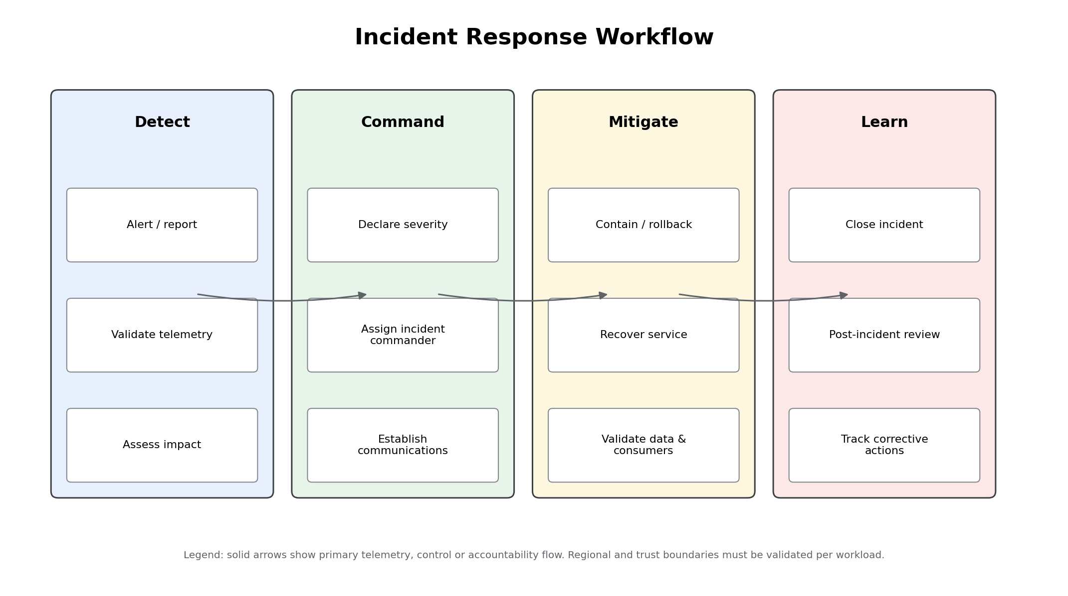
Figure 5 - Incident response workflow
Phase | Key decisions | Required evidence
Detect and validate | Is the signal real? Is telemetry healthy? What is user/business impact? | Alert, corroborating signal, service/SLO and initial scope
Declare and command | Severity, incident commander, roles, bridge and communication cadence | Incident record, role assignments and timeline
Contain and mitigate | Rollback, isolate, scale, fail over or suspend change | Commands, approvals, change/release IDs and safeguards
Recover and validate | Is the service, data and consumer journey genuinely restored? | SLO trend, reconciliation, quality and consumer confirmation
Close and learn | When is monitoring complete? What prevented or delayed recovery? | Closure decision, PIR and action tracker

Machine-readable incident event schema for integration with enterprise ITSM, analytics and audit evidence.
{
"$schema": "https://json-schema.org/draft/2020-12/schema",
"title": "EGCDP Incident Event",
"type": "object",
"required": [
"incident_id",
"service_id",
"severity",
"state",
"event_time",
"owner",
"summary"
],
"properties": {
"incident_id": {
"type": "string",
"pattern": "^INC-[0-9]{4}-[0-9]{6}$"
},
"service_id": {
"type": "string"
},
"severity": {
"enum": [
"SEV0",
"SEV1",
"SEV2",
"SEV3"
]
},
"state": {
"enum": [
"DETECTED",
"TRIAGED",
"MITIGATING",
"MONITORING",
"RESOLVED",
"CLOSED"
]
},
"event_time": {
"type": "string",
"format": "date-time"
},
"owner": {
"type": "string"
},
"summary": {
"type": "string",
"maxLength": 500
},
"customer_impact": {
"type": "string",
"maxLength": 1000
},
"runbook_id": {
"type": "string"
},
"slo_id": {
"type": "string"
},
"change_id": {
"type": "string"
},
"evidence_uri": {
"type": "string"
}
}
}

24. Problem and Change Management
Discipline | Trigger | Required action
Problem management | Repeated incidents, recurring SLO miss, chronic toil, capacity or dependency fault | Create problem record, analyze systemic cause, prioritize permanent corrective action and verify closure.
Standard change | Low-risk, repeatable and pre-approved | Automated evidence, bounded scope and rollback.
Normal change | Material production risk | Peer review, test evidence, SLO/error-budget check, owner approval and scheduled rollback window.
Emergency change | Active severe incident or urgent security exposure | Incident command approval, minimum safe review, complete evidence and mandatory retrospective.
Error-budget policy | Budget exhausted or burn trend unacceptable | Freeze nonessential risky change or obtain accountable exception with expiry and mitigation.

Change records link deployment version, Terraform plan, pipeline/model/prompt version, dashboards, SLO state and incident history. Release annotations are visible on operational dashboards. Volume 9 must implement promotion and rollback workflows that satisfy these interfaces.

25. Capacity and Performance Management
Capability | Capacity indicators | Decision
BigQuery | Queued time, reservation utilization, autoscaling, concurrency, bytes processed and workload class | Adjust assignments/reservations, optimize SQL/storage, isolate workloads or revise demand.
Dataflow | Worker utilization, autoscaling range, system lag, throughput and shuffle/state behavior | Tune workers, pipeline design, streaming mode, quotas or regional capacity.
Pub/Sub | Publish/ack throughput, backlog slope, oldest age, quota errors and subscriber capacity | Scale consumers, tune flow control, adjust quotas or partition workload.
Vertex AI | Endpoint traffic, latency, error, compute utilization, quota and model resource profile | Scale endpoints, adjust model/deployment, quotas, caching or request controls.
Observability | Metric series/cardinality, logs by class, collector saturation, query and alert inventory | Tune retention, sampling, label budget, collectors and scopes.
People/process | Page volume, MTTA/MTTR, toil, coverage gaps and training | Change staffing, automation, support tier and service design.

Capacity planning uses demand forecasts, growth scenarios, business calendars, known campaigns, recovery headroom and quota lead times. Cost is considered jointly with reliability: unused headroom is not automatically waste, but it must be linked to a service objective or recovery need.

26. Operational and Production Readiness
Gate | Minimum evidence | Decision authority
Operational Readiness Review (ORR) | Owner, tier, dependencies, telemetry contract, dashboards, alerts, on-call, runbooks, capacity, support and failure tests | Platform SRE and service owner
Production Readiness Review (PRR) | Security/privacy, data governance, deployment/rollback, SLO, error budget, DR, FinOps, operational evidence and unresolved risks | Architecture/Security/Production review authorities
Material change re-review | Changed dependency, region, model, data classification, SLO, scaling or failure behavior | Relevant service owner and control authority
Exception | Business justification, risk, compensating control, owner, expiry and remediation date | Accountable risk authority

Readiness is evidence-based. A completed checklist without alert tests, runbook exercise, rollback result and measurable SLI is not approval evidence.

27. Post-incident Review and Reliability Improvement
SEV0/1 and material SEV2 incidents require a blameless post-incident review. The objective is to understand system conditions, decisions and organizational factors, not to assign personal fault.
PIR element | Required content
Impact | Business, consumer, data, security, regulatory, region and duration.
Timeline | Detection, declaration, decisions, mitigations, recovery, validation and communication.
Detection analysis | What detected the incident, what should have, and telemetry gaps.
Contributing factors | Technical, process, ownership, capacity, dependency and change factors.
What worked/did not | Runbooks, automation, communication, access, vendor support and recovery.
Corrective actions | Owner, priority, due date, verification and linked problem/change record.
Learning distribution | Reusable pattern, standards update, training and risk-register change.

PIR metrics include detection time, acknowledgement, mitigation, recovery, time to consumer confirmation, number/age of corrective actions, recurrence and toil. MTTR is not interpreted without incident severity and scope.

28. Chaos Engineering and Resilience Testing
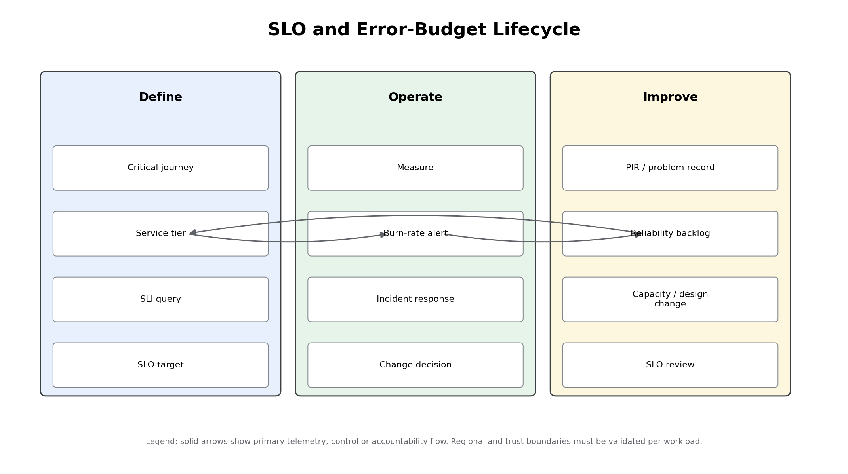
Figure 6 - SLO, error-budget and reliability improvement lifecycle
Test type | Examples | Safety requirement
Telemetry failure | Collector stopped, sink permission removed in nonproduction, notification channel disabled | Canary detects blind spot; no evidence loss in production.
Dependency degradation | Delayed source, quota reduction, downstream timeout, schema incompatibility | Bounded scope, rollback and consumer impact threshold.
Data failure | Late/duplicate records, failed quality rule, corrupt partition in test data | No production restricted data; reconciliation proves detection.
Capacity stress | Backlog, query concurrency, slot/worker saturation and endpoint load | Approved load window and stop conditions.
Regional/service exercise | Loss of regional dependency or control-plane component | Coordinate with Volume 12; no uncontrolled failover.
Human/process exercise | Pager failure, unavailable primary, vendor escalation and executive communication | Observers, explicit objectives and learning review.

Chaos is not random production disruption. Each experiment has a hypothesis, blast radius, owner, abort condition, rollback, data/security controls and measurable result.

29. Service Health, Support and Vendor Escalation
Capability | Enterprise standard
Service health | Combine consumer SLOs, regional dependency status, active incidents and service-provider health information.
Support entitlement | Map Tier 0/1 services to appropriate support plan, named contacts and escalation authority.
Vendor case | Include project/service IDs, timestamps/time zone, region, business impact, reproducible evidence, recent changes and safe diagnostics.
Escalation | Define time-based and impact-based escalation through technical account, support and executive channels.
Data handling | Sanitize attachments and logs; do not send Restricted/Regulated data without approved secure process.
Case closure | Verify resolution, document provider guidance, update runbook/risk/architecture and track recurrence.

Provider service health does not replace internal telemetry. Internal incidents may be caused by configuration, quota, identity, data contract, dependency or release failures even when the managed service is healthy.

30. Structured Service Assessments
The following assessments use the 32-field structure mandated by the master prompt. They are decision records for selected observability services and supporting technology, not generic product catalogs. Current quotas, locations, CMEK, VPC Service Controls, commercial terms and preview/GA status must be validated at implementation.

30.1 App Hub and Application Monitoring - Structured Assessment
Assessment field | Assessment
Service name | App Hub and Application Monitoring
Purpose | Organize application resources and provide application-centric operational context where available.
Enterprise architecture role | Conditional service inventory and application topology layer for business-service operations.
Business capabilities supported | Service ownership, dependency visibility and application-centric monitoring.
Technical capabilities | Application registration, services/workloads and application monitoring capabilities subject to product maturity and location.
Benefits | Connects resource telemetry to application/service context.
Limitations | Capabilities and availability may evolve; not all data/AI managed resources map uniformly.
Service quotas | Validate application/resource registration and API limits.
Regional availability considerations | Validate supported locations and data-residency behavior.
High-availability characteristics | Managed control plane; source-of-truth ownership registry must remain exportable.
Disaster-recovery considerations | Recreate application definitions from code; do not rely on it as sole dependency inventory.
Security model | IAM-scoped application visibility and metadata protection.
IAM requirements | Separate application administrator, editor and viewer roles.
Network requirements | Primarily control-plane; validate APIs and perimeter access.
VPC Service Controls considerations | Validate current support for App Hub/Application Monitoring APIs.
Encryption capabilities | Google-managed encryption.
CMEK support | Validate current support and need.
Logging | Audit administrative changes and registration actions.
Monitoring | Monitor registration drift and missing critical resources.
Alerting | Use underlying Cloud Monitoring policies; application context enriches alerts.
Cost drivers | Service and telemetry features may have product-specific costs; validate current commercial model.
Cost-optimization techniques | Register production-critical applications first; avoid stale duplicate inventories.
Operational responsibilities | Enterprise architecture owns taxonomy; service owners maintain application membership.
Integration points | Cloud Monitoring, asset inventory, service catalog and incident management.
Alternatives | Enterprise CMDB/service catalog or third-party application topology.
Selection criteria | Conditional adoption when supported and useful for business-service context.
Best practices | Treat as synchronized view, not sole source; automate registration and ownership validation.
Reference architecture | Application records connect services/workloads to dashboards, SLOs and incident records.
Sample configuration | Application resource definition maintained through supported API/IaC.
Common pitfalls | Unowned applications, stale membership, assuming full topology coverage.
Anti-patterns | Replacing the enterprise service registry without reconciliation.
Production-readiness checklist | Feature/region support, ownership sync, IAM, drift controls and exit strategy approved.

30.2 Cloud Logging - Structured Assessment
Assessment field | Assessment
Service name | Cloud Logging
Purpose | Central collection, routing, retention, search and export of platform, audit and application logs.
Enterprise architecture role | Authoritative operational and audit event pipeline with regional storage and downstream integrations.
Business capabilities supported | Troubleshooting, auditability, security detection, incident evidence and compliance retention.
Technical capabilities | Log Router, sinks, buckets, views, exclusions, log-based metrics and analytics.
Benefits | Native Google Cloud integration, centralized routing, configurable retention and access.
Limitations | Routing is not retroactive; exclusions can create evidence gaps; high log volume is costly.
Service quotas | Validate ingestion, sink, bucket, view and query limits for each region and organization.
Regional availability considerations | Use regional log buckets where residency requires; map source, storage and export destinations.
High-availability characteristics | Google-managed; customer must validate sink permissions and downstream availability.
Disaster-recovery considerations | Version sink/bucket definitions; protect exported evidence and test restore/query paths.
Security model | IAM on buckets/views, audit logs, least-privilege sink writers, sensitive-data controls.
IAM requirements | Dedicated writer identities; separate log viewer, private log viewer and configuration roles.
Network requirements | Agents/collectors require approved egress; exports require destination access.
VPC Service Controls considerations | Validate supported logging APIs and destinations across service perimeters.
Encryption capabilities | Encrypted at rest/in transit.
CMEK support | Use CMEK only where supported and justified; test key-loss and rotation scenarios.
Logging | Self-audit administrative changes to sinks, exclusions, buckets and views.
Monitoring | Monitor routed volume, errors, expected-event canaries and destination health.
Alerting | Alert on sink failures, permission denials, missing audit events and routing anomalies.
Cost drivers | Ingestion, retention, query/analytics and downstream export/storage.
Cost-optimization techniques | Exclusion filters, retention tiers, sampling non-audit debug logs, route once, avoid duplication.
Operational responsibilities | Platform owns routing; security owns audit retention; teams own application logging quality.
Integration points | Cloud Monitoring, BigQuery, Pub/Sub, Cloud Storage, SIEM and ticketing.
Alternatives | Third-party log platform or self-managed stack.
Selection criteria | Use for native service logs and centralized enterprise routing.
Best practices | Regional buckets, immutable configuration, source/category retention policy, no secrets in logs.
Reference architecture | Organization/folder sinks route to regional buckets and controlled SIEM/data-lake destinations.
Sample configuration | Terraform google_logging_organization_sink and google_logging_project_bucket_config.
Common pitfalls | Over-broad exclusions, duplicated exports, uncontrolled payloads, missing ownership.
Anti-patterns | Treating every log as permanent or sending Restricted data to uncontrolled destinations.
Production-readiness checklist | Routing map, IAM, retention, cost, expected-event tests and incident evidence controls approved.

30.3 Cloud Monitoring - Structured Assessment
Assessment field | Assessment
Service name | Cloud Monitoring
Purpose | Enterprise metrics, dashboards, uptime checks, SLOs and alerting.
Enterprise architecture role | Primary managed observability control plane for Google Cloud services and application telemetry.
Business capabilities supported | Service health, incident detection, SLO governance, executive and operator dashboards.
Technical capabilities | Metrics scopes, dashboards, alert policies, uptime checks, service monitoring, PromQL and integrations.
Benefits | Managed, deeply integrated with Google Cloud, multi-project visibility through scoped architecture.
Limitations | Central scopes require deliberate IAM, quota and residency design; service metrics vary by product.
Service quotas | Validate metrics-scope project limits, alert-policy, dashboard, API and custom-metric quotas before rollout.
Regional availability considerations | Control-plane and telemetry location behavior must be validated against data-residency requirements.
High-availability characteristics | Google-managed service; customer must design resilient notification channels and avoid single scoping-project dependencies.
Disaster-recovery considerations | Store dashboards, alerts and SLO definitions as code; use a secondary operational view for critical services.
Security model | IAM, audit logs, least-privilege viewers/editors, scoped access to sensitive telemetry.
IAM requirements | Separate monitoring viewer, editor, alert-policy author and service-account permissions.
Network requirements | Private collection paths where supported; control egress for agents and collectors.
VPC Service Controls considerations | Validate supported APIs and perimeter patterns; test collection and cross-project access.
Encryption capabilities | Google-managed encryption in transit and at rest.
CMEK support | Validate current CMEK support and scope for telemetry data before relying on it as a requirement.
Logging | Administrative and data-access audit logs where applicable.
Monitoring | Self-monitor alert delivery, metrics ingestion and telemetry canaries.
Alerting | SLO burn rate, absence, threshold, forecast and log-based signals.
Cost drivers | Custom metric volume, API usage, uptime checks and retained/processed telemetry.
Cost-optimization techniques | Prefer native metrics, control cardinality, aggregate early, delete unused dashboards/alerts.
Operational responsibilities | Platform SRE owns foundation; service owners own SLOs and response.
Integration points | Cloud Logging, Managed Prometheus, OpenTelemetry, service metrics, notification systems and SIEM.
Alternatives | Third-party observability suite or self-managed Prometheus/Grafana.
Selection criteria | Use as system of record for Google Cloud operational health and common alerting.
Best practices | Regional scoping projects, ownership metadata, alerts-as-code, tested notification channels.
Reference architecture | Regional observability projects aggregate domain/service telemetry into controlled enterprise views.
Sample configuration | Terraform google_monitoring_alert_policy with user_labels and runbook link.
Common pitfalls | Orphan alerts, infrastructure-only dashboards, unbounded custom labels.
Anti-patterns | One global project with broad viewer access and no residency/access analysis.
Production-readiness checklist | Scope, IAM, alerts, dashboard ownership, notification tests, cost baseline and canary passed.

30.4 Cloud Trace - Structured Assessment
Assessment field | Assessment
Service name | Cloud Trace
Purpose | Distributed tracing and latency analysis for applications and service interactions.
Enterprise architecture role | Trace plane for user journeys, APIs, event handlers and AI/agent orchestration where supported.
Business capabilities supported | Faster root-cause analysis and dependency/latency optimization.
Technical capabilities | Trace ingestion, span analysis, latency distributions and integrations with OpenTelemetry.
Benefits | Managed tracing integrated with Google Cloud.
Limitations | Sampling can hide rare events; data and AI managed services expose varying trace granularity.
Service quotas | Validate trace ingestion, API and retention limits.
Regional availability considerations | Validate data location and cross-region trace routing requirements.
High-availability characteristics | Managed backend; collectors/SDKs need retry and non-blocking failure behavior.
Disaster-recovery considerations | Tracing is diagnostic, not transactional; store configuration as code and maintain log/metric fallback.
Security model | Do not put secrets, raw payloads or regulated data in span attributes.
IAM requirements | Scoped trace agent/viewer roles.
Network requirements | Collectors/SDKs require approved API connectivity.
VPC Service Controls considerations | Validate trace APIs and exporters within service perimeters.
Encryption capabilities | Encrypted at rest/in transit.
CMEK support | Validate current support before adoption as a requirement.
Logging | Trace SDK/collector errors to Cloud Logging.
Monitoring | Trace ingestion success, sampling rate and exporter failures.
Alerting | Use metrics for paging; traces primarily support diagnosis.
Cost drivers | Trace volume and collector/network overhead.
Cost-optimization techniques | Risk-based sampling and attribute allowlists.
Operational responsibilities | Platform sets standards; teams define critical journeys and span boundaries.
Integration points | OpenTelemetry, Cloud Monitoring, Cloud Logging and Error Reporting.
Alternatives | Third-party APM or self-managed tracing backend.
Selection criteria | Use for latency-sensitive service and agent journeys.
Best practices | Correlate trace ID in logs, consistent service names, bounded attributes and sampling.
Reference architecture | OTel-instrumented services export spans through regional collectors.
Sample configuration | OTel SDK resource attributes and collector trace exporter.
Common pitfalls | Sampling without documented rationale; high-cardinality/span payload leakage.
Anti-patterns | Paging directly on individual traces or tracing every payload field.
Production-readiness checklist | Critical journeys, sampling, privacy, correlation and exporter failure tests approved.

30.5 Error Reporting - Structured Assessment
Assessment field | Assessment
Service name | Error Reporting
Purpose | Group and surface application errors from supported logs and error events.
Enterprise architecture role | Developer and operator triage aid for application/runtime failures.
Business capabilities supported | Faster detection and diagnosis of recurring software errors.
Technical capabilities | Error grouping, stack traces, notifications and links to logs.
Benefits | Low-friction integration with Cloud Logging and runtimes.
Limitations | Not a replacement for SLOs, incident management or complete exception telemetry.
Service quotas | Validate event ingestion and API limits.
Regional availability considerations | Validate service availability and telemetry location requirements.
High-availability characteristics | Managed service; ensure errors are also visible through logs/metrics.
Disaster-recovery considerations | No unique recovery dependency; maintain source logs and code versions.
Security model | Stack traces may contain sensitive values; sanitize messages and restrict access.
IAM requirements | Scoped error viewer/editor roles.
Network requirements | Application logging path must be available.
VPC Service Controls considerations | Validate supported access patterns.
Encryption capabilities | Encrypted at rest/in transit.
CMEK support | Depends on underlying logging support; validate current behavior.
Logging | Consumes supported error logs/events.
Monitoring | Track error-event delivery and unexpected grouping changes.
Alerting | Use for actionable new/high-rate error groups, not all exceptions.
Cost drivers | Underlying logging/telemetry volume.
Cost-optimization techniques | Deduplicate, sample noisy expected errors and fix root causes.
Operational responsibilities | Application teams own triage; SRE governs severity and incident linkage.
Integration points | Cloud Logging, issue trackers and source repositories.
Alternatives | Third-party APM/error tracker.
Selection criteria | Use as supplemental application-error view.
Best practices | Structured errors, release/version labels, ownership and runbook links.
Reference architecture | Application errors flow to Cloud Logging and Error Reporting; SLO metrics drive pages.
Sample configuration | Structured log event with service, version, trace and exception.
Common pitfalls | Alerting every error, missing release version, leaking data in stack traces.
Anti-patterns | Treating grouped errors as availability or business-impact SLOs.
Production-readiness checklist | Access, sanitization, ownership, notification and incident-linking tested.

30.6 Google Cloud Managed Service for Prometheus - Structured Assessment
Assessment field | Assessment
Service name | Google Cloud Managed Service for Prometheus
Purpose | Managed collection, storage and query of Prometheus-format metrics.
Enterprise architecture role | Standard Kubernetes and open-source workload metrics plane integrated with Cloud Monitoring.
Business capabilities supported | Application and infrastructure reliability for GKE, hybrid and portable workloads.
Technical capabilities | Managed collectors, self-deployed collectors, PromQL, rule evaluation and multi-project monitoring.
Benefits | Prometheus compatibility without operating a complete metrics backend.
Limitations | Cardinality and scrape design remain customer responsibilities; collection modes require planning.
Service quotas | Validate time-series ingestion, label/cardinality and query limits.
Regional availability considerations | Validate collection and storage location behavior for residency-sensitive workloads.
High-availability characteristics | Managed backend; collectors need multi-zone design and buffering expectations.
Disaster-recovery considerations | Configuration as code; redeploy collectors and rules; maintain critical fallback signals.
Security model | Workload Identity, least-privilege metric writer/viewer and protected endpoints.
IAM requirements | Metric writer for collectors; scoped viewer/query roles for operators.
Network requirements | Collectors need connectivity to scrape targets and Google APIs through approved paths.
VPC Service Controls considerations | Validate telemetry ingestion/query across perimeters and hybrid collectors.
Encryption capabilities | Encrypted in transit and at rest.
CMEK support | Validate current support before making CMEK mandatory.
Logging | Collector and rule-evaluator logs to Cloud Logging.
Monitoring | Monitor scrape health, collector queue, ingestion failures and cardinality.
Alerting | PromQL alerting policies and SLO burn-rate rules.
Cost drivers | Ingested samples/time series and related monitoring usage.
Cost-optimization techniques | Drop unused metrics, control label cardinality, tune scrape intervals, recording rules.
Operational responsibilities | Observability platform owns standard; workload teams own instrumentation and target health.
Integration points | Cloud Monitoring, GKE, OpenTelemetry, Grafana and incident tooling.
Alternatives | Self-managed Prometheus/Thanos or third-party metrics platform.
Selection criteria | Use where Prometheus ecosystem compatibility is required.
Best practices | Managed collection by default, controlled relabeling, label budget and rules-as-code.
Reference architecture | Regional collectors feed managed backend and enterprise metrics scope.
Sample configuration | PodMonitoring/ClusterPodMonitoring plus PromQL alert policy.
Common pitfalls | User IDs in labels, scraping high-cardinality endpoints, no scrape-health alert.
Anti-patterns | Operating duplicate Prometheus backends without a migration or ownership plan.
Production-readiness checklist | Collection mode, identity, network, cardinality, PromQL rules and failure tests approved.

30.7 OpenTelemetry - Structured Assessment
Assessment field | Assessment
Service name | OpenTelemetry
Purpose | Vendor-neutral instrumentation and collection for metrics, logs and traces.
Enterprise architecture role | Enterprise telemetry contract and portability layer for applications and data/AI services.
Business capabilities supported | Consistent observability across Google Cloud, hybrid and multi-cloud workloads.
Technical capabilities | SDKs, semantic conventions, Collector receivers/processors/exporters, sampling and enrichment.
Benefits | Open standard, reusable instrumentation and controlled routing.
Limitations | Collector lifecycle, resource sizing, config testing and semantic governance remain customer-owned.
Service quotas | Downstream backend quotas and collector resource limits must be modeled.
Regional availability considerations | Deploy collectors regionally; prevent unintended cross-border export.
High-availability characteristics | Run collectors redundantly; design queues, retries and backpressure.
Disaster-recovery considerations | Configuration and images stored immutably; redeploy per region; maintain direct critical-path metrics where justified.
Security model | mTLS/TLS, workload identity, secret management, payload filtering and least privilege.
IAM requirements | Export identities limited to telemetry write permissions.
Network requirements | Private endpoints or controlled egress; firewall and DNS must support exporters.
VPC Service Controls considerations | Validate exporters against perimeter restrictions.
Encryption capabilities | TLS for collection/export; backend encryption applies at destination.
CMEK support | Depends on destination backend; collector itself does not provide storage CMEK.
Logging | Collector self-logs with sensitive payload controls.
Monitoring | Queue depth, dropped spans/metrics/logs, exporter errors, memory and CPU.
Alerting | Collector saturation, export failures and drop-rate thresholds.
Cost drivers | Collector compute/network and downstream telemetry volume.
Cost-optimization techniques | Tail/head sampling, batching, attribute filtering, aggregation and compression.
Operational responsibilities | Platform publishes golden collector; teams instrument to contract.
Integration points | Cloud Trace, Cloud Monitoring, Managed Prometheus, Cloud Logging and third-party tools.
Alternatives | Vendor-specific agents and SDKs.
Selection criteria | Use for new application/agent instrumentation and multi-cloud portability.
Best practices | Approved semantic conventions, resource attributes, PII filtering, config validation and canary.
Reference architecture | Regional gateway collectors receive OTLP and export to managed Google Cloud backends.
Sample configuration | Collector YAML with memory limiter, batch, resource processor and Google exporters.
Common pitfalls | No queue persistence, unbounded attributes, secrets in spans/logs.
Anti-patterns | Every team invents its own attributes and collector topology.
Production-readiness checklist | Schema, security, capacity, sampling, failure behavior and downstream routing tested.

31. Architecture Decision Records
ADR | Decision | Status
ADR-1101 | Adopt regional observability projects with controlled enterprise aggregation | Accepted - architecture baseline
ADR-1102 | Use business-service SLOs and error budgets as the primary reliability control | Accepted - architecture baseline
ADR-1103 | Centralize log routing regionally with tiered retention | Accepted - architecture baseline
ADR-1104 | Standardize on OpenTelemetry and Managed Service for Prometheus | Accepted - architecture baseline
ADR-1105 | Page on user impact and SLO burn rate, not raw resource thresholds | Accepted - architecture baseline
ADR-1106 | Manage observability configuration as versioned code | Accepted - architecture baseline
ADR-1107 | Adopt federated operations with central platform SRE and product on-call | Accepted - architecture baseline
ADR-1108 | Treat telemetry as governed enterprise data | Accepted - architecture baseline
ADR-1109 | Use gated and reversible operational automation | Accepted - architecture baseline
ADR-1110 | Require evidence-based ORR, PRR and post-incident improvement | Accepted - architecture baseline

Complete ADRs using all mandated fields are included in the adrs/ directory. They must be reviewed when current product capabilities, locations, regulation, pricing, support model or enterprise tooling changes.

ADR-1101: Adopt regional observability projects with controlled enterprise aggregation
Field | Content
Status | Accepted - architecture baseline
Domain | Observability
Problem | A single global observability plane can conflict with data residency, least privilege and blast-radius requirements.
Alternatives considered | Single global observability project; Independent domain-only monitoring; Regional projects with controlled aggregation
Decision | Use AMER, EMEA and APAC observability projects and logging locations, with carefully scoped enterprise aggregation for approved operational metadata.
Tradeoff | Regional deployment adds governance and duplication, but provides clearer residency, access and failure boundaries.
Implementation implication | Publish versioned standards/templates, onboard Tier 0/1 first, and integrate ownership/SLO/runbook metadata with service management.
Review trigger | Major incident, repeated SLO miss, region or regulation change, product capability change or material cost/support change.

Full record: adrs/ADR-1101_*.md

ADR-1102: Use business-service SLOs and error budgets as the primary reliability control
Field | Content
Status | Accepted - architecture baseline
Domain | SRE governance
Problem | Infrastructure uptime does not adequately represent data freshness, quality, analytics availability or AI service outcomes.
Alternatives considered | Infrastructure-only thresholds; Contractual SLAs only; Business-service SLOs with error budgets
Decision | Define SLOs at business-service and data-product boundaries, backed by component indicators; use error budgets to govern change and reliability work.
Tradeoff | Requires ownership and instrumentation maturity; prevents teams from optimizing components while consumers are failing.
Implementation implication | Publish versioned standards/templates, onboard Tier 0/1 first, and integrate ownership/SLO/runbook metadata with service management.
Review trigger | Major incident, repeated SLO miss, region or regulation change, product capability change or material cost/support change.

Full record: adrs/ADR-1102_*.md

ADR-1103: Centralize log routing regionally with tiered retention
Field | Content
Status | Accepted - architecture baseline
Domain | Logging
Problem | Uncontrolled project-local logs impede incident response, audit and cost governance.
Alternatives considered | Project-local logging; Single worldwide bucket; Regional centralized routing
Decision | Use organization/folder sinks into regional log buckets and controlled SIEM/archive destinations; apply tiered retention and carefully reviewed exclusions.
Tradeoff | Misconfigured sinks or exclusions can create evidence gaps; telemetry canaries and configuration-as-code mitigate.
Implementation implication | Publish versioned standards/templates, onboard Tier 0/1 first, and integrate ownership/SLO/runbook metadata with service management.
Review trigger | Major incident, repeated SLO miss, region or regulation change, product capability change or material cost/support change.

Full record: adrs/ADR-1103_*.md

ADR-1104: Standardize on OpenTelemetry and Managed Service for Prometheus
Field | Content
Status | Accepted - architecture baseline
Domain | Telemetry
Problem | Multiple agents, SDKs and metric formats create duplicated cost, inconsistent labels and vendor lock-in.
Alternatives considered | Vendor-specific agents only; Self-managed Prometheus/Thanos; OpenTelemetry plus managed Google Cloud backends
Decision | Use OpenTelemetry semantic conventions and collectors for new applications, and Managed Service for Prometheus where Prometheus compatibility is needed.
Tradeoff | Collector operations and label governance remain customer responsibilities.
Implementation implication | Publish versioned standards/templates, onboard Tier 0/1 first, and integrate ownership/SLO/runbook metadata with service management.
Review trigger | Major incident, repeated SLO miss, region or regulation change, product capability change or material cost/support change.

Full record: adrs/ADR-1104_*.md

ADR-1105: Page on user impact and SLO burn rate, not raw resource thresholds
Field | Content
Status | Accepted - architecture baseline
Domain | Alerting
Problem | Static infrastructure thresholds generate noise and fail to represent urgency.
Alternatives considered | Threshold-only paging; Manual dashboard review; SLO burn-rate and symptom-based paging
Decision | Use multi-window burn-rate alerts and user-impact signals for paging; route capacity and cost signals to tickets unless immediate impact exists.
Tradeoff | Some services lack direct SLI signals; approved proxy indicators are required.
Implementation implication | Publish versioned standards/templates, onboard Tier 0/1 first, and integrate ownership/SLO/runbook metadata with service management.
Review trigger | Major incident, repeated SLO miss, region or regulation change, product capability change or material cost/support change.

Full record: adrs/ADR-1105_*.md

ADR-1106: Manage observability configuration as versioned code
Field | Content
Status | Accepted - architecture baseline
Domain | DevSecOps
Problem | Manual dashboards, alerts and sinks are difficult to review, promote, reproduce and recover.
Alternatives considered | Console-only management; Central manual operations team; Infrastructure/configuration as code
Decision | Store alert policies, dashboards, SLOs, log routing, collectors and notification metadata in source control and promote through environments.
Tradeoff | Volume 9 and Volume 13 implementation pipelines remain dependencies.
Implementation implication | Publish versioned standards/templates, onboard Tier 0/1 first, and integrate ownership/SLO/runbook metadata with service management.
Review trigger | Major incident, repeated SLO miss, region or regulation change, product capability change or material cost/support change.

Full record: adrs/ADR-1106_*.md

ADR-1107: Adopt federated operations with central platform SRE and product on-call
Field | Content
Status | Accepted - architecture baseline
Domain | Operating model
Problem | A central team cannot understand or operate thousands of pipelines and data products alone.
Alternatives considered | Central NOC owns all; Domain-only operations; Federated SRE ownership
Decision | Central SRE owns shared observability and incident standards; platform and domain/product teams own their services, SLOs, runbooks and on-call.
Tradeoff | Requires skills, staffing and explicit escalation boundaries.
Implementation implication | Publish versioned standards/templates, onboard Tier 0/1 first, and integrate ownership/SLO/runbook metadata with service management.
Review trigger | Major incident, repeated SLO miss, region or regulation change, product capability change or material cost/support change.

Full record: adrs/ADR-1107_*.md

ADR-1108: Treat telemetry as governed enterprise data
Field | Content
Status | Accepted - architecture baseline
Domain | Security and governance
Problem | Logs, traces and metrics can contain identifiers, prompts, queries, schema names and regulated information.
Alternatives considered | Unrestricted telemetry collection; Disable diagnostic detail; Governed telemetry contract
Decision | Classify telemetry, enforce attribute allowlists, regional routing, retention, access controls and sensitive-data prevention.
Tradeoff | Filtering can reduce diagnostic detail; teams must design safe correlation identifiers.
Implementation implication | Publish versioned standards/templates, onboard Tier 0/1 first, and integrate ownership/SLO/runbook metadata with service management.
Review trigger | Major incident, repeated SLO miss, region or regulation change, product capability change or material cost/support change.

Full record: adrs/ADR-1108_*.md

ADR-1109: Use gated and reversible operational automation
Field | Content
Status | Accepted - architecture baseline
Domain | Automation
Problem | Automatic remediation can reduce MTTR but can amplify faults or destroy evidence.
Alternatives considered | Fully manual response; Unrestricted auto-remediation; Gated reversible automation
Decision | Allow automation only for bounded, tested and reversible actions; destructive or cross-region actions require approval and evidence.
Tradeoff | Human gates may increase response time for some scenarios.
Implementation implication | Publish versioned standards/templates, onboard Tier 0/1 first, and integrate ownership/SLO/runbook metadata with service management.
Review trigger | Major incident, repeated SLO miss, region or regulation change, product capability change or material cost/support change.

Full record: adrs/ADR-1109_*.md

ADR-1110: Require evidence-based ORR, PRR and post-incident improvement
Field | Content
Status | Accepted - architecture baseline
Domain | Operational assurance
Problem | Checklists without evidence do not prove operability or sustained improvement.
Alternatives considered | Informal peer review; Document-only checklist; Evidence-based operational gates
Decision | Require measurable SLOs, alert tests, runbook exercises, rollback evidence and action tracking before production and after major incidents.
Tradeoff | Adds delivery effort but reduces preventable production failure.
Implementation implication | Publish versioned standards/templates, onboard Tier 0/1 first, and integrate ownership/SLO/runbook metadata with service management.
Review trigger | Major incident, repeated SLO miss, region or regulation change, product capability change or material cost/support change.

Full record: adrs/ADR-1110_*.md

32. Risks and Mitigations
ID | Risk | Impact | Mitigation | Owner | Status
R-1101 | Telemetry blind spot caused by failed agent, sink, quota, IAM or routing | High | Synthetic telemetry canaries, routing health checks, dual-path critical audit logs, tested runbook | Observability Platform | Open
R-1102 | Alert fatigue hides true incidents | High | SLO/burn-rate alerts, deduplication, ownership, quarterly alert review, no orphan alerts | SRE Council | Open
R-1103 | High-cardinality metrics create cost and performance issues | Medium | Metric allowlist, label budget, cardinality tests, aggregation and sampling | Observability Platform | Open
R-1104 | Centralized observability violates residency or least privilege | High | Regional telemetry projects, filtered aggregation, scoped access, documented residency mapping | Security Architecture | Open
R-1105 | Domain teams treat platform SRE as sole operator | High | Federated ownership, product on-call, SLO accountability, RACI and readiness gates | CDO/SRE | Open
R-1106 | Automation amplifies incident impact | High | Gated reversible automation, blast-radius limits, approval for destructive actions, audit logs | Platform SRE | Open
R-1107 | SLOs are infrastructure-only and miss business impact | High | Business-service SLIs at data-product and consumer boundaries | Service Owners | Open
R-1108 | Monitoring cost grows without control | Medium | Retention tiers, exclusion filters, metric governance, usage dashboards, FinOps reviews | FinOps | Open
R-1109 | PIRs do not lead to improvement | Medium | Action owner, due date, verification, trend reporting, recurring-problem governance | Problem Manager | Open
R-1110 | Volume 9 CI/CD controls are not yet implemented | High | Treat observability-as-code gates as implementation dependency and track to Volume 9 | DevSecOps | Open

33. Implementation Roadmap
Phase | Name | Indicative Duration | Outcomes
0 | Mobilize and baseline | 2-4 weeks | Service inventory, ownership, tiering, current telemetry assessment, critical gaps
1 | Observability foundation | 6-8 weeks | Regional observability projects, metrics scopes, logging buckets/sinks, IAM, retention, cost guardrails
2 | SLO and alerting MVP | 6-10 weeks | Tier 0/1 SLOs, error budgets, burn-rate alerts, dashboards, on-call and runbooks
3 | Data/AI observability scale-out | 8-12 weeks | Freshness, quality, lineage, BigQuery, Dataflow, Pub/Sub, Vertex AI operational signals
4 | Operational governance | 6-8 weeks | ORR/PRR, PIR, problem/change/capacity processes, vendor escalation, service health
5 | Resilience and automation | Ongoing | Chaos tests, failure injection, gated remediation, cross-region exercises, optimization

Wave | Priority services/data products | Exit criteria
Pilot | One Tier 0 streaming product, one Tier 1 batch product, BigQuery platform and observability foundation | Measured SLOs, tested alerts, runbooks, on-call, regional routing and cost baseline.
Scale 1 | All Tier 0 shared platforms and top regulated products | Portfolio command center, incident/PIR process and readiness evidence.
Scale 2 | Remaining Tier 1 products, analytics and AI endpoints | Federated ownership and standard telemetry contracts.
Optimize | Tier 2/3 rationalization and legacy-tool convergence | Reduced duplicate tools/noise, cost/cardinality optimization and resilience maturity.

34. Validation Criteria and Acceptance Tests
ID | Test | Acceptance
VAL-001 | Generate synthetic success/failure/freshness signals and prove the SLI query calculates the expected ratio/window. | SLO result matches test data and documentation.
VAL-002 | Trigger each page-level alert in a controlled environment. | Correct owner/channel receives page with severity, service, runbook and deduplication.
VAL-003 | Stop or isolate a regional OpenTelemetry collector. | Secondary path or alert detects drops before the approved blind-spot threshold.
VAL-004 | Break a logging sink writer permission in nonproduction. | Expected-event canary detects the routing failure and runbook identifies IAM cause.
VAL-005 | Create Pub/Sub backlog and Dataflow lag under approved load. | Dashboard correlates signals; page occurs only when service SLO is at risk.
VAL-006 | Exhaust an error budget in test data. | Change policy, dashboard and exception workflow behave as approved.
VAL-007 | Insert prohibited sensitive/high-cardinality attributes into telemetry contract test. | Validation fails without exposing values.
VAL-008 | Run SEV1 exercise through incident declaration, communication, mitigation and PIR. | Timeline, roles, evidence and actions satisfy the template.
VAL-009 | Verify regional access personas and denied cross-region/log access. | Least privilege and residency controls work as designed.
VAL-010 | Restore observability configuration from repository into a clean project. | Dashboards, alerts, sinks and SLO definitions reproduce successfully.
VAL-011 | Test primary notification-channel failure. | Fallback channel and escalation operate within response target.
VAL-012 | Review telemetry cost and cardinality against approved budget. | Usage is attributable; anomalies and top contributors are actionable.

Post-deployment smoke-test starter for policy inventory, telemetry canary and runbook metadata.
#!/usr/bin/env bash
# Purpose: post-deployment observability smoke tests.
set -euo pipefail

: "${PROJECT_ID:?set PROJECT_ID}"
: "${SERVICE_ID:?set SERVICE_ID}"
: "${CANARY_METRIC:=custom.googleapis.com/observability/canary_age_seconds}"

echo "Validating active alert policies..."
gcloud monitoring policies list --project "${PROJECT_ID}" \
--filter="userLabels.service=${SERVICE_ID}" --format="value(name)" | grep -q .

echo "Validating recent telemetry canary..."
gcloud monitoring time-series list \
--project "${PROJECT_ID}" \
--filter="metric.type=\"${CANARY_METRIC}\"" \
--interval="start-time=$(date -u -d '10 minutes ago' +%FT%TZ),end-time=$(date -u +%FT%TZ)" \
--format=json | python3 -c 'import json,sys; assert len(json.load(sys.stdin)) > 0'

echo "Validating runbook labels are present..."
gcloud monitoring policies list --project "${PROJECT_ID}" --format=json | \
python3 -c 'import json,sys; p=json.load(sys.stdin); assert all(x.get("userLabels",{}).get("runbook_id") for x in p if x.get("enabled", True))'

echo "Observability smoke tests passed."

35. Production Readiness Checklist
ID | Control | Classification | Evidence
PR-001 | Business service owner, technical owner and on-call are recorded | Mandatory | Ownership registry
PR-002 | Service tier, dependencies, RTO/RPO and critical user journeys are approved | Mandatory | Service record
PR-003 | SLIs and SLOs are measurable from production telemetry | Mandatory | SLO configuration and query
PR-004 | Burn-rate alerts route to tested notification channels | Mandatory | Alert test evidence
PR-005 | Runbooks exist for every page-level alert | Mandatory | Runbook catalog
PR-006 | Metrics, logs and traces use approved naming and label budgets | Mandatory | Telemetry review
PR-007 | Sensitive data is excluded, redacted or access-controlled in telemetry | Mandatory | Privacy/security review
PR-008 | Regional logging, retention and residency are documented | Mandatory | Logging design
PR-009 | Dashboards separate user impact from component health | Mandatory | Dashboard review
PR-010 | Capacity and cost thresholds are baselined | Mandatory | Capacity model
PR-011 | Failure, rollback and recovery paths are tested | Mandatory | Exercise evidence
PR-012 | ORR/PRR evidence is approved before production | Mandatory | Signed review
PR-013 | PIR process and action tracking are operational | Mandatory | PIR template and tracker
PR-014 | Vendor support and escalation routes are documented | Mandatory | Support plan
PR-015 | Observability configuration is versioned and promoted through controlled environments | Mandatory | Repository and release evidence

36. Dependencies, Decisions and Next Actions
Dependency | Required interface
Volume 4 Data Engineering | Pipeline IDs, metrics, data-quality/freshness events, replay and runbooks.
Volume 5 Data Mesh | Data-product owner, SLO, consumer impact and certification status.
Volume 6 Analytics | Looker/BigQuery operational experience, dashboard/query SLO and KPI correctness.
Volume 7 AI/GenAI | Endpoint, model, pipeline, RAG/agent, evaluation and safety metrics.
Volume 8 Security | Audit, SCC, identity/perimeter/key activity, incident and telemetry data protection.
Volume 9 DevSecOps - pending | Observability-as-code validation, promotion, release annotation and rollback evidence.
Volume 10 FinOps | Telemetry cost, capacity economics, anomaly and unit cost.
Volume 12 DR | Recovery SLO/RTO/RPO, regional exercises and incident/recovery orchestration.
Volume 13 Terraform | Golden modules for monitoring, logging, collectors, IAM and dashboards.

Prioritized next actions:
- Approve the federated SRE operating model and service-owner accountability.
- Select pilot Tier 0/1 services and baseline their critical user journeys and telemetry gaps.
- Create AMER, EMEA and APAC observability project designs and validate location, IAM, perimeter and quota constraints.
- Publish telemetry contract, SLI/SLO template, alert severity model, runbook and incident/PIR templates.
- Implement observability-as-code pipelines as part of the outstanding Volume 9 and Volume 13 work.
- Execute controlled alert, telemetry-failure and incident-command exercises before production approval.
- Establish monthly service reliability review and quarterly observability cost/cardinality review.

37. References and Companion Assets
Official Google Cloud references to validate during implementation:
- Google Cloud Monitoring documentation, metrics scopes, alerting and service monitoring.
- Cloud Logging routing, sinks, buckets, retention, exclusions and log-based metrics.
- Google Cloud Managed Service for Prometheus managed collection, multi-project monitoring and PromQL.
- OpenTelemetry Collector and Google Cloud exporters/instrumentation guidance.
- Cloud Trace and Error Reporting documentation.
- BigQuery monitoring and INFORMATION_SCHEMA operational views.
- Dataflow monitoring, job metrics and user counters.
- Pub/Sub monitoring metrics and operational guidance.
- Vertex AI monitoring for endpoints, pipelines, model monitoring and operations.
- Google Cloud Architecture Framework - operational excellence, reliability, security and cost optimization.
- Google SRE guidance for service-level objectives, error budgets, incident response and postmortems.
Companion package contents:
- Six diagrams in PNG, SVG, Mermaid, PlantUML, Graphviz DOT and editable draw.io formats.
- Nine implementation starters for OpenTelemetry, Monitoring, Logging, SLOs, PromQL, dashboards, incident schema and validation.
- Seven 32-field service assessments, ten complete ADRs, eight matrices, runbook templates, manifest and checksums.
Current product terminology and capabilities can change. Before implementation, validate official documentation, release stage, regional availability, quotas, IAM, VPC Service Controls, CMEK, retention, pricing and support commitments.

